The International College of Economics and Finance
Econometrics – 2020-2021
Midterm Exam, April 1, 2021.
(One session 2 hours without break)

General instructions.

To understand well the structure of this exam please read carefully this instruction

Candidates should answer THREE of the following FIVE questions

Section A

Choose and answer ONE question from questions 1-2 (questions on Time Series Models)
using appropriate form titled ‘Question 1’ OR ‘Question 2’

answer obligatory question 3 (question on Panel Data Models)
using form titled ‘Question 3’

Section B

Choose and answer ONE question from questions 4-5
(questions on topics of the first semester)
using form ‘Section B’ - clearly indicate your choice

Each question bears equal number of marks. Divide your time properly.

Structure your answers in accordance with the structure of the questions.

When testing hypotheses always state clearly null and alternative hypotheses, provide with critical value used for test, indicating degrees of freedom and the significance level chosen for the test.

Always indicate part of the question you answer (a, b, c).

You may use during exam arithmetic or scientific calculator (without programming capabilities).

SECTION A
Choose and answer ONE question from questions 1-2 (Time series models)
using appropriate form titled ‘Question 1’ OR ‘Question 2’

AND answer the obligatory question 3 (Panel data models)
using form titled ‘Question 3’

Question 1. (By choice) The student is interested in studying how the relative prices of wine influence its consumption in France. She's considering two alternative regression models - simple linear regression (1) and model in differences (2) - using data on wine consumption 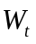 (in billions of euro) subject to the relative price index of wine, 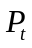 on the base of annual data (1995-2018), variable  in 1995, 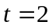 in 1996 etc.
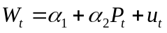 (1)
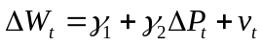 (2 )
where 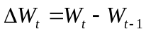, 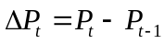, and 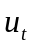, and 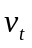 are disturbance terms.
Estimating these equations she obtained
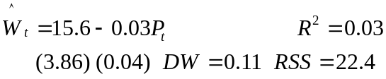 (1e)
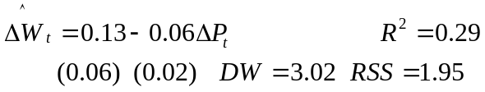 (2e)
(a) The supervisor advised the student to check the time series for stationarity and said that probably her estimated regression (1e) is spurious regression.

□ What is stationarity? Why it is important? Which model in level does difference model (2) correspond?

□ The student argued that the equation (1e) is insignificant, so the regression cannot be spurious. Do you agree with her? What is spurious regression? How to tell whether some estimated regression based on time series is spurious?

□ Explain how spurious regression can occur if the condition of stationary of time series is violated?

(b) The student decided to test the time series for stationarity by constructing the following Dickey-Fuller equations

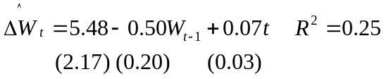 (3e) 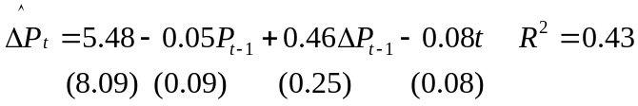 (5e)

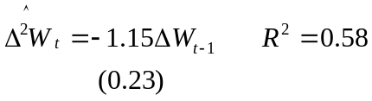 (4e) 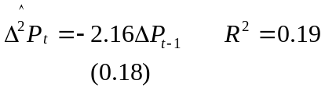 (6e)

□ Explore Dickey-Fuller equation models mathematically. How the model corresponding (3e) can be derived from the original AR specification? State null and alternative hypotheses and decision rule; explain the logic of Dickey-Fuller test based on ADF t-statistic (not doing the test itself).

□ What is the difference between the specification of equation (3e) and the specification of equation (5e)? How null and alternative hypotheses change? Does each of these specifications have any advantages (and possible disadvantages)?

(c) □ Interpret the results of the estimation of Dickey-Fuller equations using ADF t-statistic. What are your conclusions: which of the time series are stationary and which are non-stationary? Explain.

Question 2. (By choice). The student is interested in studying how the relative prices of wine influence its consumption in France. She's considering several alternative regression models using data on wine consumption (in billions of euro) subject to the relative price index of wine using annual data (1995-2018).
She starts from an ADL(1,1) model (1), and considers as its alternatives two simplified models: simple linear regression (2) and model in differences (3).
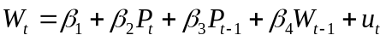 (1)
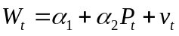 (2)
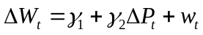 (3)
where 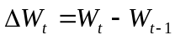, 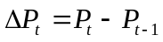, and , , and 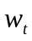 are disturbance terms.

Estimating these equations she obtained
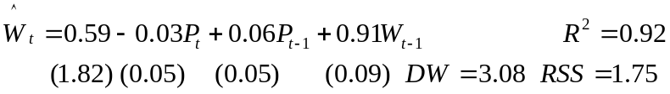 (1e)

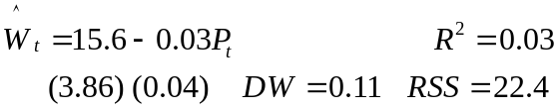 (2e)

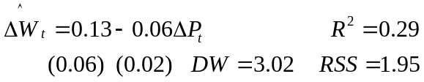 (3e)

(a) □ Show that (2) and (3) are restricted versions of (1), what are the restrictions?

□ Test these restrictions. Which of these tests could be done using either 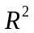 or 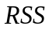 and which can be done using only one of these indicators?

(b) □ Test the equations (1e-3e) for autocorrelation in the following order: first test (2e), then (3e) and finally (1e).

□ Assuming in turn correctness of equations specification and taking into account your conclusions above explain what problems, if any, would be encountered if ordinary least squares were used to fit equations (2), (3), (1)? (consider each of them in turn from (2), then passing to (3) and finally (1)). What are their comparative advantages and disadvantages?

(c) The student decided to apply Common Factor Test to the model (1) estimating the restricted version of the equation (1)
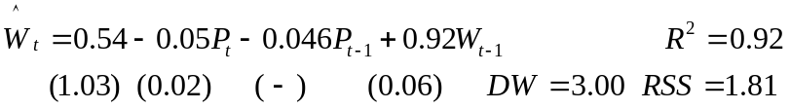 (1Re)

□ What is the restriction? Why there is no standard error for coefficient of 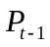 in equation (1Re)?

□ Help her to run Common Factor test, giving test statistic and decision rule.

□ The student told you that coefficient 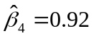 of the variable 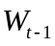 in (1Re) can be always interpreted as autocorrelation coefficient, so the estimate of autocorrelation coefficient is equal to 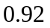. Comment the student’s idea of running Common Factor Test in the situation under consideration and her conclusion.

Question 3. (Obligatory question) The student of the course ‘Elements of Econometrics’ 2019-20 decided to estimate influence of the attendance of seminars in Econometrics  (in absolute numbers in the first module – before October exam and in the second module – before December exam) and the quality of the home assignments 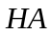 (measured by the average grade per semester – from 0 to 100) on the grade 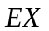(from 0 to 100) obtained at the corresponding exam. She collected data as follows (all calculations were made on the basis of real data of autumn 2019 for 209 students for those all data were available – balanced panel).
Let the model under consideration be
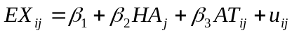;
where 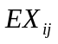 - the result of the exam 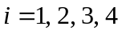 (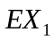 - Multiple choice test result in October 2019, 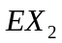 - Free Responce result in October 2019, 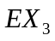 – MCh result in December 2019, 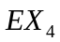 – FR result in December 2019), 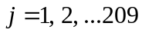, 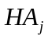 is the average score for Home Assignments for the first semester for student , 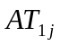 is the number of weeks when student attended seminars in module 1, 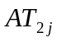 is the number of seminars attended by student in module 1 (including repeated attendance), 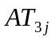 and 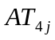 are the same for the module 2.
The student uses three alternative approaches to the evaluation of this model: 1) pooled OLS regression, 2) fixed effects panel regression model, and 3) random effects panel regression model. The results of the estimation are shown below

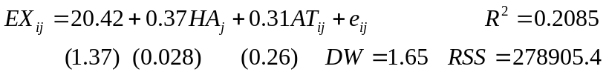; (1 - Pooled)

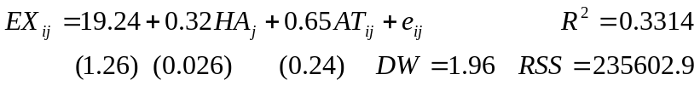; (2 - Fixed)

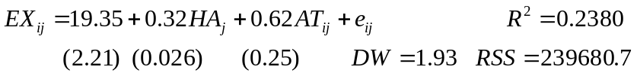; (3 - Random)

(for simplicity, you can assume that the LSDV approach is used when evaluating the fixed effects model)

(a) □ The student remembers that the panel data are characterized by unobserved heterogeneity, but none of estimated equations (1)-(3) contained information about it. Explain to the student the differences between the three methods, stating the reason for the absence of unobserved heterogeneity term in the results.

□ Consider LSDV fixed effect model, comment on the estimates of coefficients including constant term. Fixed effects estimates are also provided by computer program: 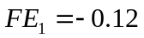, 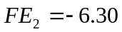, 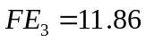, 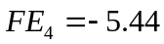 (see coding of four exams 1-4 above). What conclusions about the comparative complexity of the examination tasks can be drawn from examining fixed effects? Explain your reasoning.

(b) □ Help the student to choose between equation (2) (fixed effects model), and equation (3) (random effects model) using Hausman test. The value of test statistic for the Hausman test was evaluated as 12.36. Comment on the idea of the test, assumptions used and results.

□ Help the student to choose between models (1) and (2). Do appropriate F test and make a conclusion. Сomment on the idea of the test used. What is your final choice between equations (1-3)?

(c) □ Estimate the significance of the regression equation (2) using F-statistic (indicate test statistics, degrees of freedom and critical values).

□ Answer to the main question of the research – does the attendance matter? Comment on the fact that only panel data models allow to state the significance of the coefficient of the attendance 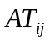.

SECTION В
Answer only ONE question from this section (question 4 OR question 5)
using form ‘Section B’ - clearly indicate your choice in the form

Question 4. (By choice). A student for her diploma paper evaluates the production function for the economy of a small European country whose main source of income is tourism. She has data on the total investments T in the tourism industry, G - gross domestic product (GDP), as well as the population P of the country for 47 years (in your answer the issues of stationarity of time series should be neglected). T and G are both measured in billions of euro, P is measured in millions. Hypothesizing that investments in tourism per capita depends on GDP per capita, she fits the regression (RSS = residual sum of squares):
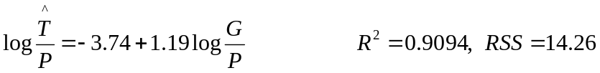 (1)
She also runs the following regressions:
(2)
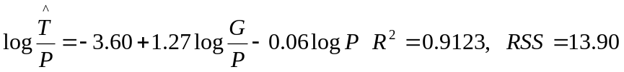 (3)

(a) □ What is the difference in economic meaning of the slope coefficients in equations (1) and (2)? Assume all coefficients are significant.

□ Explain why coefficient of variable 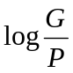 in equation (3) is equal to the coefficient of variable 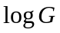 in equation (2).

□ Suggest possible explanation to the fact that the coefficient of variable 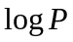 in equation (2) is negative.

(b) □ Demonstrate mathematically that equation (1) is a restricted version of equation (3), stating the restriction.

□ Test the restriction, using an F test.

□ The supervisor told the student that her calculation of equation (3) was unnecessary; all of its coefficients can be clearly seen from equation (2). Comment on this.

(c) □ Demonstrate mathematically that equation (1) is a restricted version of equation (2), stating the restriction.

□ Test the restriction, using an F test. Which of two F tests in (b) and (c) can be done only using RSS, and which using either RSS or 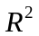?

Question 5. (By choice). The researcher studies the factors that determine people’s satisfaction with their lives using the sample data from the Russian Longitudinal Monitoring of Economic Situation and Health (RLMS-HSE) - 13647 people for a certain year.

Descripion of variables:
Happy (binary dependent variable) - life satisfaction at the moment (1 - satisfied, 0 - dissatisfied);
AGE - respondent's age (number of full years);
MALE - Gender (1 - male, 0 - female);
EMP – employment (1 - yes, 0 - no);
REL - Religion Index according to the respondent's assessment (from 0 (atheist) to 5 - strictly observes all rites of his/her religion);
HEALTH - Health Index according to the respondent's assessment: (from 0 - very bad, to 5 - very good) ;
SMOKE - (1- smokes, 0 - not);
ALCO - (1 - consumes alcohol, 0 - not);
MAR - (1 - married, 0 - not married);
KIDS - number of children;
WAGE - salary per month in thousand rubles.

Regression | (1) |  | (2) |  | (3) |  | (4)
 | OLS |  | OLS |  | LOGIT |  | LOGIT
 | Coefficient | s.e. | Coefficient | s.e. | Coefficient | s.e. | Coefficient | s.e.
C | 0.18 | 0.026 | 0.16 | 0.025 | -1.38 | 0.12 | -1.48 | 0.11
AGE | 0.00056 | 0.00030 |  |  | 0.0018 | 0.0013
ALCO | -0.028 | 0.0090 | -0.025 | 0.0090 | -0.12 | 0.039 | -0.11 | 0.039
EMP | 0.041 | 0.012 | 0.039 | 0.012 | 0.27 | 0.057 | 0.27 | 0.056
HEALTH | 0.16 | 0.0067 | 0.16 | 0.0057 | 0.70 | 0.031 | 0.70 | 0.026
KIDS | 0.023 | 0.0046 |  |  | 0.10 | 0.020
MALE | -0.029 | 0.0092 |  |  | -0.12 | 0.041
MAR | -0.090 | 0.010 |  |  | -0.40 | 0.045
REL | -0.027 | 0.0044 | -0.025 | 0.0043 | -0.12 | 0.020 | -0.11 | 0.019
SMOKE | 0.095 | 0.010 | 0.080 | 0.0098 | 0.38 | 0.046 | 0.36 | 0.043
WAGE | 0.0033 | 0.00029 | 0.0035 | 0.00028 | 0.018 | 0.0016 | 0.019 | 0.0016
R-squared | 0.089 |  | 0.083
McFadden R-squared |  |  |  |  | 0.068 |  | 0.063
F-statistic | 133.35 |  | 204.76
LR statistic |  |  |  |  | 1293.10 |  | 1199.75

(a) Consider regression (1) (all its coefficients except AGE are significant at 5%).
□ Give interpretation to the numerical values of some coefficients of regression (1) (no more than 2, one of them should be of dummy variable). In a couple of sentences, summarize in simple language the main results of the study that you find most interesting.

□ Demonstrate mathematically that the heteroscedasticity is present in the data

(b) □ R-squared for regressions (1) and (2), and McFadden R-squared for regressions (3) and (4) all are very low. Can we conclude from this that the regressions are insignificant?

□ Consider a group of demographic variables AGE, KIDS, MALE, MAR. Are these variables significant individually and considered together as a group of variables in regressions (1) and (3)? Explain your work.

(c) □ The researcher wants to use regression (3) to calculate the probability of being happy for a non-smoking, but alcohol consuming man of 40 years with a good health index (HEALTH = 3) and moderately religious (REL = 1), married with one child, and having job with a salary of 25 thousand rubles per month. Help him to do this.

□ How this probability changes in case of losing a job (keeping ALL other factors constant)?

□ The reviewer, checking your calculation in the article submitted for publication, reasonably noticed that the man under consideration, having lost his job, at the same time lost his monthly salary of 25 thousand rubles, whereas the calculation performed earlier does not take this into account. Correct the previous result using any appropriate method.

